Art 101 Writing Assignment
2.5-3 Pages
Hard Copy Due Wednesday, 4/3/19

https://www.artsy.net/article/artsy-editorial-scandal-sleepwalker-foreshadowed-todays-culture-wars

We think of outdoor public sculpture as having commemorative or memorial purposes. Think of our own John Wilkes, by Butler, near the library.

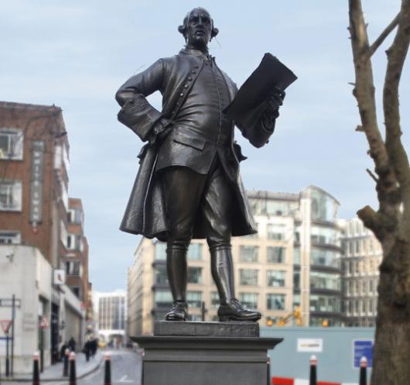

There was some controversy a few years back revolving around a sculpture temporarily installed on the grounds of Wellesley College. The sculpture is titled Sleepwalker by contemporary artist Tony Matelli. The hyper-realistic sculpture is shown below at two locations: one at the college campus in 2014, where it was part of a larger exhibit (mostly an indoor gallery exhibit); and later on New York City’s High Line, a public walking space.

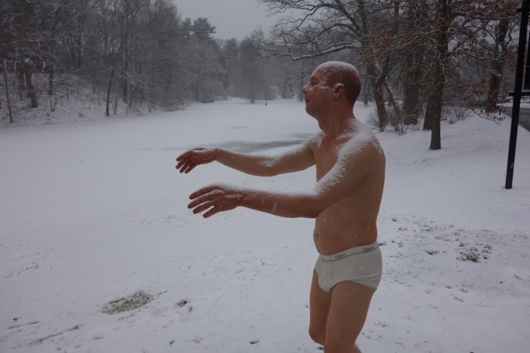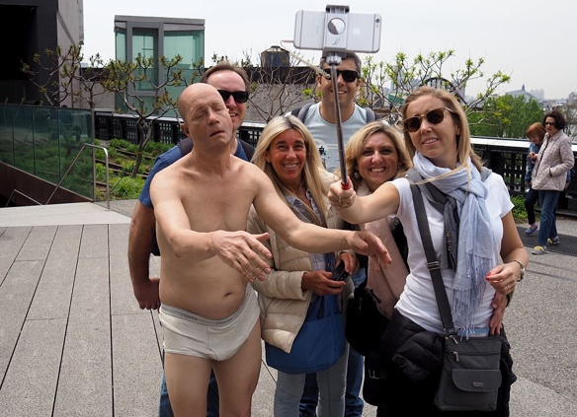

Read the attached article (link above) and write your paper beginning with a brief overview of the sculpture and the two locations. Then elaborate on the controversy and give where you stand on the issue. Keep in mind the temporary nature of the college campus location. Also address the overall difference between both locations and how it changes perceptions of the sculpture. Lastly, how does this sculpture differ from the Wilkes statue. What if Butler made his sculpture hyper-real like Matelli did?

